# **CTF Topic: Code Analysis**



# **Introduction**

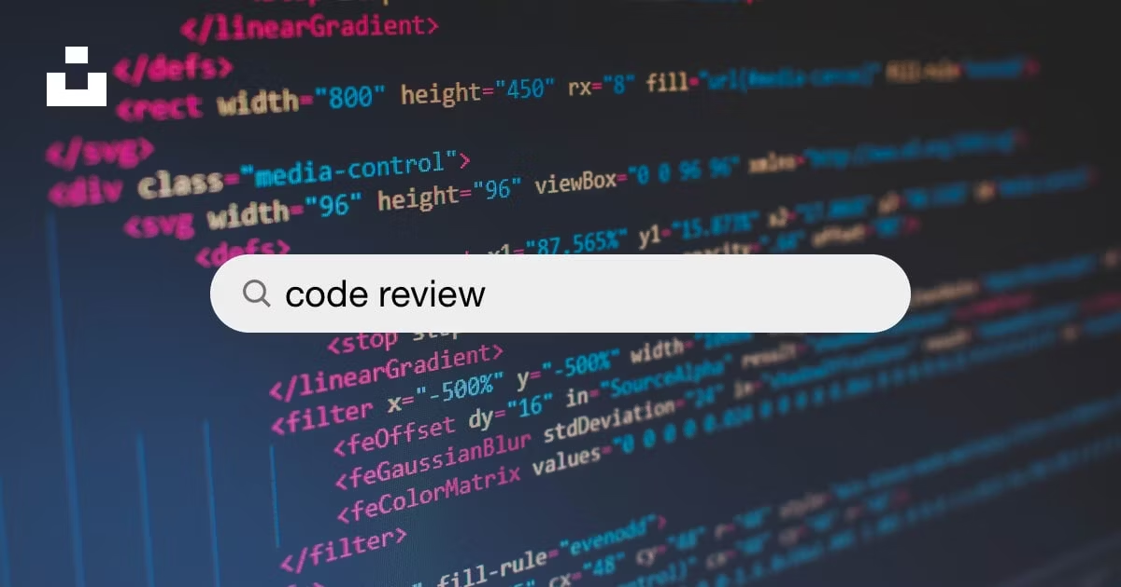

Code analysis, also known as static code analysis, is the process of examining source code without executing it to identify potential defects, security vulnerabilities, and other quality issues. This technique is used to improve the quality and reliability of software by detecting issues early in the development cycle, leading to cost savings and reduced time-to-market.

# **Tools and requirements**

Code

<https://www.techopedia.com/definition/29997/source-code-analysis>

# **Scenario**

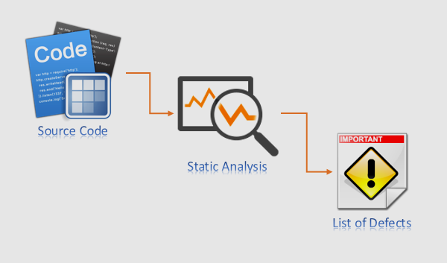

The manager of the company has given the task to Sachin to review the code of backend. He found the code has so many flaws and errors and can be exploited through different vulnerability tactics. The manager has ordered him to analyze the code and make corrections within 24 hours and should submit the code with zero vulnerabilities otherwise he would be fired from the job if he couldn’t complete his task. So, he started analyzing the code.

# **Process to Perform**

Download the code from the given lin: and analyze it.

<https://www.mediafire.com/file/gvaqznd5bilizn2/COD_analysis.pdf/file>

# **Let’s start the Challenge**

# **Question**

Flag 1: What is the username and password to authenticate with MySQL server.

Answer: user: clocky_user

Password: db

Flag Captured

Flag 2: What is the name of the database?

Answer: Clocky

Flag Captured

# **Hint**

